Assignment 5

In this capture there are 3ip’s involved. The clients ip is172.16.0.107 which communicates with the server whose ip is 12.153.20.41. This client also interacts with the ip 74.125. 95.147.

Clients ip address communication:-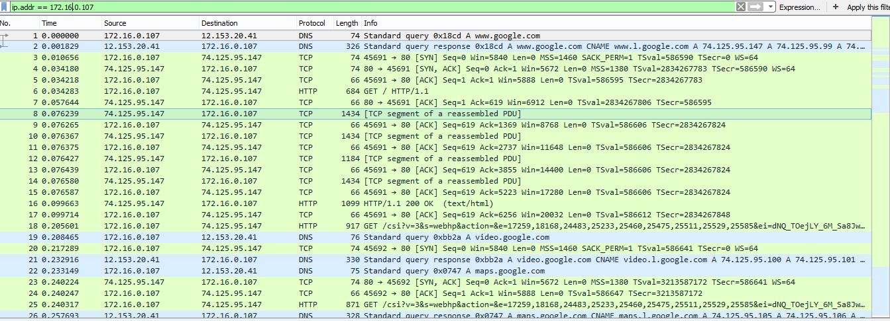

Server ip address communication:-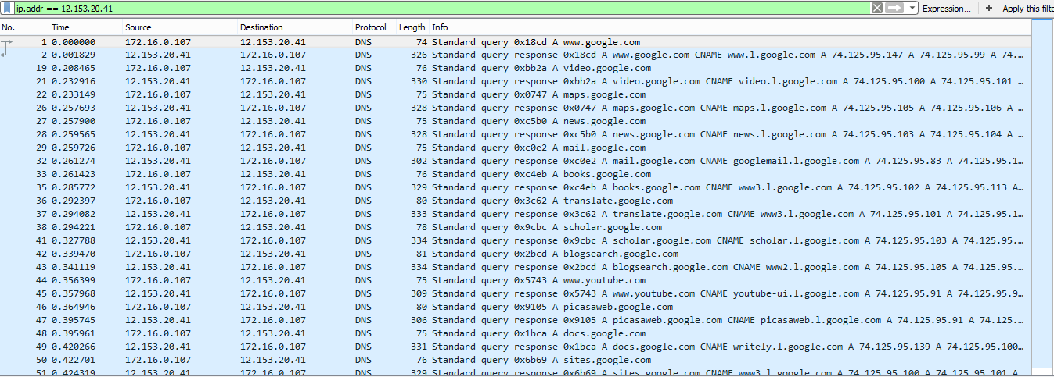

Communication of ip address 74.125. 95.147. 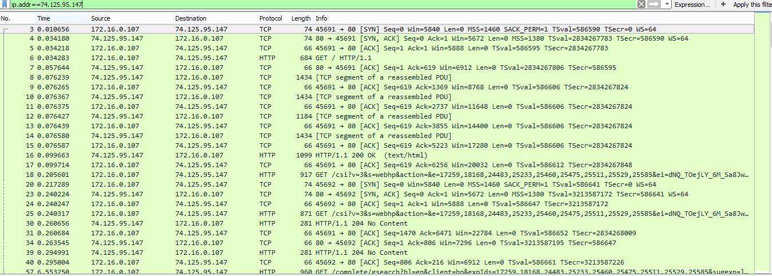

By checking out network conversations we find the following conclusions:-

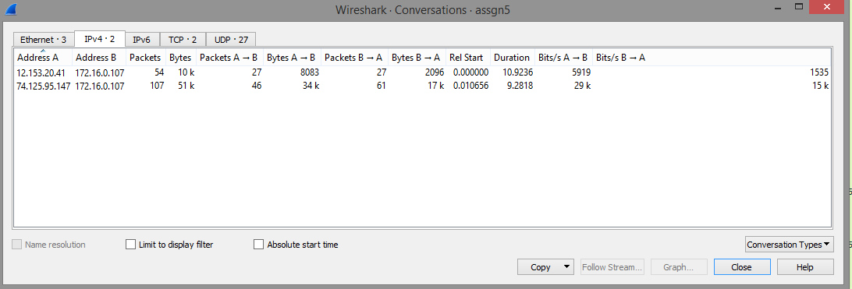

By this we can conclude that 172.16.0.107 is the highest talker in the conversation.